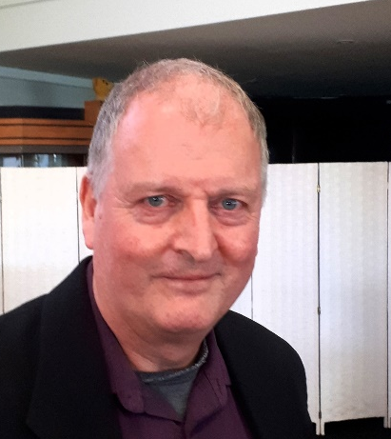
Matthew Wright - speech notes
Those Who Have the Courage
Launch – 5 April 2024

Thank you for coming. I’m Matthew Wright, author of ‘Those Who Have the Courage’.
To introduce myself, I was brought up in Napier. My education was originally in physics and music. I ditched music at university for degrees in history and studied historical methodology post-graduate under Peter Munz, himself a student of both Karl Popper and Ludwig Wittgenstein. Popper, a refugee of the Jewish diaspora escaping the Nazis in the 1930s, invented current scientific method – the principle of a test for falsification. This, of course, applies to historical analysis as much as to the sciences. Munz, among many other things, taught me a good deal about historical methodology – not just the techniques, but also the need for reason and reasonableness.
Since then I’ve written a fair number of history books, including four on the New Zealand wars; two biographies of Bernard Freyberg; a study of the impact of the First World War on our soldiers; and a general history of New Zealand that’s still in print after two decades. Some of my books have been used as core university texts, and I’ve been publishing, of late, internationally.
I started full-time work on ‘Those Who Have the Courage’ in November 2019. Fifty three months, a pandemic, a recession, and more than a third of a million words later, it’s in print. And the work has been intensely challenging and rewarding in equal measure.
I’d like to take this opportunity to extend my thanks to all involved from the RNZAC History Project Charitable Trust, and those who have contributed to their project over the past four and a half years.
I’m not going to list everybody, their names are in the book – but a few do need highlighting. I particularly thank Graeme Ready, Chris Wotton and Trevor McComish; and those I had less contact with whose efforts made it possible to write the book for the Trust to the depth and scale achieved. I’ve thoroughly enjoyed working with these people.
I also thank those who assisted my digging out the relentless piles of documentation on which I based my work – again, as listed in the book, but I’d particularly like to thank Dolores Ho of the Kippenberger Archive for her tremendous support.
Along the way I sought peer review and advice from trusted colleagues, particularly my friend Christopher Pugsley, who is New Zealand’s leading military historian. Other commentary came from overseas. Stephen Badsey of the University of Wolverhampton, in particular, commented on my draft text – and very positively. He is one of the world’s experts on the evolution of mobility in the field from the 1870s to the First World War.
I also want to thank Peter Dowling and Oratia Books for their support. I particularly thank Carolyn Lagahetau, my editor, for her excellent work, patience and wisdom. I first worked with Carolyn over 25 years ago, when she was at Reed, and as always it was a pleasure to work with her.
Now, a book of this kind – pitched for the everyday reader – nonetheless demanded particular focus on the methodology and techniques of academic history - and, at times, some very heavy technical lifting. To simply list events was not enough: the book had to explain, giving context and place to the story.
These challenges were multiplied by patchy data. The records covering the RNZAC Directorate, it turned out, had been destroyed. Other data was incomplete or inconsistent, even down to spelling names within the same files. Sorting this out demanded I apply highest levels of critical analysis in order to assess the quality of sources.
All this was necessary to give meaning to the broad sweep of events: three centuries during which the volunteer, mounted and armoured forces ultimately operated globally. For all the scale of final product, there wasn’t room to say much about any one person, story or event. This was not to slight anybody, but a practical reality: the focus was always on frameworks of understanding, knowing that these in turn give depth to information known to readers that may not be in the book, but which gains value in turn.
In writing this book I was able to ‘bust’ many mythologies. For instance, I was able to prove that New Zealand’s practical involvement with armour began during the First World War. Why? Well, there is the Battle of Cambrai, in which some Kiwi tankers fought, which remains integral to Corps subculture.
But more crucially, New Zealanders served with the infant Tank Corps and the effort to raise a New Zealand tank force in 1918. This has been well known to historians but never put into context of the Kiwi armoured story. All represented a draw on the New Zealand taxpayer, making this work part of New Zealand’s military history in fiscally real sense.
Another area I felt deserved reconsideration was the Palestine campaign of 1917. This has long called for new insights, and I was able to identify an angle which, I hope, will develop the historiography of this ‘forgotten war’ – one prosecuted in part by our mounted forces. It was, again, politicised: the words “crusaders” and “Balfour Declaration” were pertinent. However, the troopers did not share those sentiments, and you’ll have to read the book for why.
I’ll mention a final example. I explored a recent argument over the Gallipoli participation rate – and thus, casualty percentages. A 2020 study by NZDF re-estimated the participation figure, confirming an analysis I published in 2017 that casualties were about sixty percent, not the ninety-plus assumed previously.
While researching ‘Those Who have the Courage’ I found period data not used by the NZDF’s historians. From this I was able to discover the actual numbers and loss-rates of the mounted forces at Gallipoli. These stood at – wait for it - ninety-plus percent. This was in line with the discredited mythology. But these figures were real. The question I then had to answer was why the mounted formations suffered so disproportionately?
I found the answers were not due to any lack of calibre. Quite the opposite. Courage, determination and raw bravery were watchwords. Today, those battles – especially the fight for Hill 60 – stand proudly among the honours of the Corps, and rightly so.
To finish, I have to again acknowledge the work done by the History Project Charitable Trust. I was able to write a book of around 350,000 words, five times the length of a typical publication today, materially longer than some recent military histories produced at taxpayer expense. The funding came through hard work by the Trust, seeking support from private and corporate sources to whom I am, of course, most grateful.
Finally, it became clear as I wrote the book that I was recording the evolution and deeds of a unique part of New Zealand’s military story. It has been an honour and a privilege to have opportunity to write about such an extraordinary corps. I am grateful and humbled to have been a part of this project.
Thank you.

